HYBRID POWER SYSTEMS FOR BUILDINGS AND FACTORIES

Chung-Jen Tseng^{a,b,*}, Cheng-I Chen^{b,c}, Cheng-You Yaoª, Kan-Rong Lee^{a,d}, Cang-Rong Liuª

ª Department of Mechanical Engineering, National Central University, Taoyuan City, Taiwan
^{b} Center for Energy Research, National Central University, Taoyuan City, Taiwan
^{c} Department of Electrical Engineering, National Central University, Taoyuan City, Taiwan
^{d} Institute of Materials Science and Engineering, National Central University, Taoyuan City, Taiwan
* cjtseng@ncu.edu.tw (C-J Tseng)

Integrated hybrid power systems have become more and more important in recent years. In this work, four different hybrid power systems are proposed and analyzed by using Matlab/Simulink/Thermolib. Off the four configurations, System A is combined with a micro turbine. In order to reduce carbon emission and increase system economic benefits, the micro turbine is replaced by a methanol synthesis reactor in Systems B, C, and D. In System B, as shown in Fig. 1, the methanol reactor is placed directly after the fuel cell. The unused fuel is burned in a burner to provide heat for the reformer. In System C, a water separator is placed ahead of the methanol synthesis reactor to filter out water content in the exhaust flow from the fuel cell. On the other hand, a hydrogen transfer membrane (HTM) is used to separate hydrogen from other components. The separated H₂ is reacted with CO₂ in the methanol reactor, while the remaining components is sent to a water gas shift reactor (WGS) to produce more H₂. Although the configuration of the four systems is different, but they are analyzed under the same operating conditions.

Results show that system A has the highest net power output due to the additional contribution from the micro turbine. The poor methanol production of system B leads to the lowest system efficiency. For system C, with the water separator filtering out the water, the methanol production increases significantly, and therefore system C has the highest combined heat and power efficiency. For system D, due to the addition of HTM and WGS, the methanol production rate is the highest among systems B, C, and D. As shown in Fig. 2, System D also has the highest carbon reduction rate.

System A

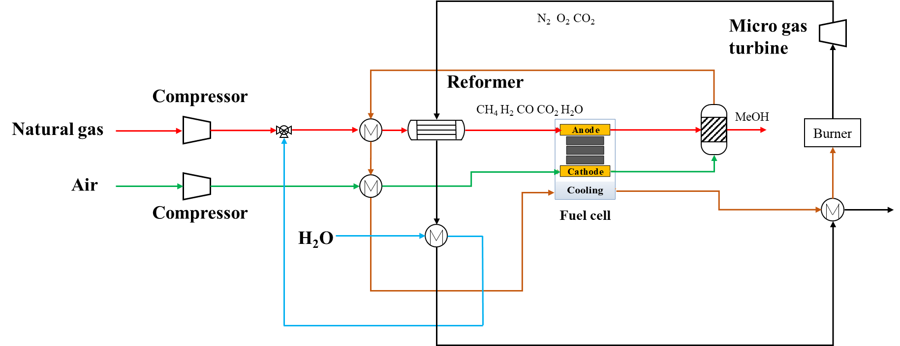
System B

Fig 1. Configurations for Systems A and B

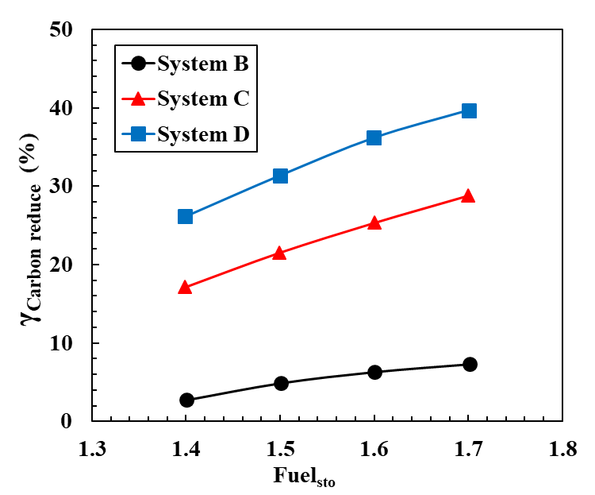
Fig 2. Comparison of carbon reduction rates at different fuel stoichiometric ratio

