A TECHNIQUE FOR BUILDING LONG-TERM PREDICTIVE SCENARIOS OF WATER AVAILABILITY AND TEMPERATURE CONDITIONS
Abasov N.V., Berezhnykh T.V., Nikitin V.M., Osipchuk E.N.
Melentiev Energy Systems Institute SB RAS, Irkutsk, Russia

Simulation of long-term operation of an electric power system with a high proportion of hydroelectric power plants (HPPs), characterized by considerable interannually and seasonally uneven inflows into the reservoirs of the plants, requires sufficiently reliable long-term forecast scenarios of water availability and temperature conditions in the winter heating period.
The Melentiev Energy Systems Institute SB RAS has developed methods, models, methodology and the information and forecasting system “GIPSAR” for making reliable long-term estimates of environmental factors in the energy sector, which are based on a systems approach to the extraction of the most useful information from the statistical data collected [1]. The methodology includes approximate learning methods in combination with qualitative and probabilistic approaches that search and use the cause-effect relationships and spatial-temporal patterns. Previously, this methodology made it possible to build acceptable aggregate prognostic estimates (for a year or more) for many quasi-stationary processes (for example, estimates of the total annual inflow into the HPP reservoirs and average winter temperatures that affect energy consumption during the heating period).
Unfortunately, the global and regional climate changes have considerably reduced the reliability of long-term prognostic estimates, because many previously found cause-effect relationships and spatial-temporal patterns have altered, and the amount of statistical data collected in a new environment is small. For example, a long dry period that started on Lake Baikal in 1996, including the extremely low-water years 2014–2018 led to a decrease in the rate of annual usable inflow into the lake by more than 10% compared to the previous one. The statistical data did not contain an analog of such a period.
We have developed a new long-term forecasting system (GeoGIPSAR) to increase the reliability of the long-term prognostic estimates of water content and temperatures under current conditions. The use of this system in energy research is noted in [2]. This system additionally includes an air condition database (many meteorological parameters of NCEP/NCAR reanalysis data for the whole world with their daily monitoring and on-line updating tools), data on meteorological and gauging stations, as well as a lot of geo- and solar-indices, such as solar activity, lunar cycles, the speed of the Earth's rotation, etc.
The developed system also includes a database of ensemble forecasts. This database is updated via Internet monitoring of data generated by global climate models, for example, the CFS-2 model, which is used to simulate the air and ocean conditions on a daily (or several-hour) basis for a period of up to 9–10 months according to a special technique designed to consider various disturbing factors. The scatter of the indices of individual ensemble forecasts can vary within wide limits, which complicates their direct use in the practical estimation of meteorological and hydro indices. The method developed for processing a great number of individual ensemble forecasts within the GeoGIPSAR system makes it possible to form the most probable spatial distributions of meteorological indices through their aggregation (with different weights) for given periods. For example, the climate maps of absolute and relative indices are built for each month. They show the boundaries of river catchment basins. The tools are also developed to form the temporal dynamics of changes in studied indices for specific points and individual territories.
Figure 1 presents a schematic diagram of the long-term scenario construction process. It is based on a synthesis of 2 fundamental approaches: 1) the development of predictive methods using the approximate and probabilistic methods devised previously and new methods of neural networks; and 2) the construction of prognostic maps of meteorological indices based on the aggregation of individual sets of ensemble forecasts (for example, the formation of averaged indices for a selected time interval).
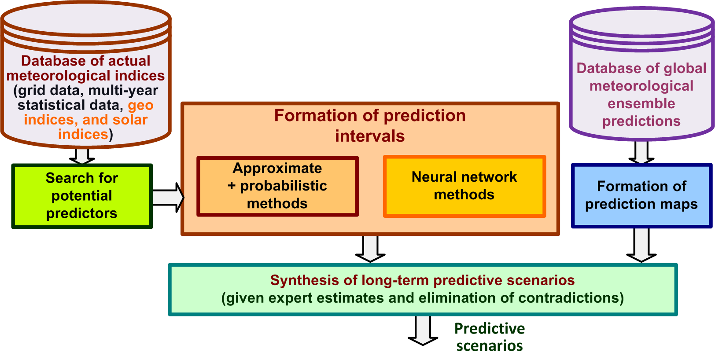
Fig. 1. The scheme for building the long-term predictive scenarios of water inflows into the reservoirs of HPPs and temperature conditions during the heating season

While the approximate and probabilistic methods rely on the search for patterns in the distant past, the neural network methods implemented in the GeoGIPSAR system have a multi-parameter structure (many hidden layers with different numbers of neurons and various logistic functions). The neural network methods are characterized by employing nonlinearities of logistic functions used, which allow adjusting the outputs to intervals with different quantization parameters. The neural networks developed for interval estimation are normally easily trained on various data samples. Reliable prognostic estimates are obtained by selecting only those parameters of the neural network and affecting factors that have the least errors in various verification samples.
The final synthesis of predictive scenarios is determined based on expert estimates on data processing by various methods, considering verification on various subsamples and elimination of contradictions (for example, the contradiction between the expected high water content and elevated temperatures at the same time).

References
1. Berezhnykh T., Abasov N., The Increasing Role of Long-Term Forecasting of Natural Factors in Energy System Management // International Journal of Global Energy Issues, Vol. 20, No. 4, 2003. P. 353–363.
2. Abasov N.V., Nikitin V.M., Osipchuk E.N. A System of Models to Study Long-Term Operation of Hydropower Plants in the Angara Cascade // Energy Systems Research, Vol. 2, Number 2(6), 2019. P. 5–18.

