Application of Digital Technologies for Expansion Planning of Integrated Energy Systems
Valery Stennikov¹, Nikolai Voropai¹, Evgeny Barakhtenko^{1,*}, Dmitry Sokolov¹, Oleg Voitov¹, Bin Zhou²
¹Melentiev Energy Systems Institute of Siberian Branch of the Russian Academy of Sciences, Irkutsk, Russia
²Hunan University, Changsha, China
Abstract. Active promotion of digital technologies in the energy sector requires a change in the principles of building energy systems, as well as the concept of their expansion planning. The functioning of infrastructural energy systems that are transforming as a result of the innovative development is fundamentally impossible without advanced information and communication technologies and intelligent digital tools. Energy systems are becoming sophisticated cyber-physical systems. At the same time, the problems of cybersecurity are exacerbating. The joint functioning of several types of energy systems in the form of a single integrated energy system provides new functional capabilities. The use of digital technologies in integrated energy systems provides the collection, processing, transmission and representing of information on all components of the system regarding all aspects of integration. Digitalization of integrated energy systems is carried out in the following two directions: application of digital technologies for individual subsystems for the purpose of their control; the use of digital technologies for technical and technological integration solutions in order to ensure coordination of subsystems and the implementation of system-wide goals. The adoption of digital technologies in integrated energy systems contributes to the organization of flexible, coordinated control of the expansion planning of such systems.

1 Introduction
Modern cities and industrial centers have a developed energy infrastructure, including fuel, electricity, heat and cold supply systems. These systems have a certain functional independence and can interact with each other in normal and emergency conditions, as well as at the level of interchangeability of primary energy resources and the use of energy carriers. All this shows their natural integration, which is even more intensified as the formation and development of intellectual, information, telecommunication systems. Jointly they present a new structure in the form of integrated energy systems. This structure combines a certain independence of the systems with their coordinated participation in the solution of the main problem related to ensuring of social and economic activity. The quality of its solution is ensured by the use of digital technologies. Control of digital integrated energy systems is an urgent and complex problem.
2 Characteristics of studies on the integrated energy systems
Energy systems, primarily electricity, heat supply, gas supply and oil supply systems, perform an important infrastructural function. This function is to ensure energy supply to consumers with the required reliability and quality of energy carriers. Traditionally, these systems are integrated in the production of electricity and heat at CHP plants using gas as a fuel. The potential for the integration of electricity, heat and gas supply systems at the level of energy consumption has emerged as a result of the development of technologies and mechanisms. Alternative possibilities for consumers are in the choice of energy use devices for the same purposes - centralized heat supply from a CHP or electric heating, electric or gas stoves for household consumers, etc. As a result, the integration of energy supply systems at the levels of energy production and consumption leads to the need to jointly consider these systems as integrated in solving the tasks of their expansion planning and operation control [1-4, etc.]. The integration of energy systems served as an impetus for the formation and development of the concept of an energy hub [5-7, etc.].
Considering a set of tasks of control of integrated energy systems, it is advisable to divide these tasks into two groups: expansion planning of intelligent integrated energy systems and operation control.
As the analysis of the literature carried out in [4, 8] shows, the main attention of the authors is concentrated on the tasks of operation control, while the calculation of the flow distribution and its optimization in the integrated energy system is considered as the basic task. On this basis, other tasks of operation control of the integrated energy system are formulated and solved, in particular, the optimization of daily modes during their dispatching, the analysis of the reliability of energy supply, etc. The group of tasks under consideration is solved taking into account the various components of the integrated energy system: electricity and heat supply systems; electricity, water, and gas supply; electricity and gas supply; electricity, heat and cold supply; etc.
Research has been carried out to analyze integrated energy systems taking into account the activity of consumers in control of their energy consumption, the use of energy storage devices, modern information and communication technologies, etc. [9, 10]. Mainly used are network models of flow distribution, including with the integration of models of interconnected energy systems into a general model [8]. A fractal approach to modeling large integrated electric-thermal networks is considered [11]. A simulation model of an integrated energy system based on the concept of an energy hub is proposed [12]. To optimize modes, both classical methods of mathematical programming and evolutionary algorithms are used.
With regard to the methodology and tasks of expansion planning of integrated energy systems, it is advisable to pay attention primarily to the review [13] concerning the tasks of expansion planning of cities based on the integration of energy supply systems. In general, this work reflects the interpretation of the traditional methodology for expansion planning of energy systems, taking into account the multicriteria nature of tasks under various scenarios of external conditions with the optimization of target indicators for the efficiency of expansion planning of integrated energy supply systems, reducing harmful emissions and stimulating the use of renewable energy resources. In [14], the task of joint expansion planning of electric and gas transmission networks at endogenously set market prices for gas, taking into account their volatility due to network restrictions, is considered. In [15], an innovative architecture of an intelligent integrated energy system and its control system is proposed based on the principles of a cellular structure, symmetric (multidirectional) energy flows, automatic reconfiguration of the network in emergency modes, network-centric ideology of control and self-regulation, etc.
Summing up, it should be noted that the methodology and tasks of expansion planning of integrated energy systems have been worked out significantly less compared to the methodology and tasks of their operation control.
3 Background and benefits of energy digitalization
First of all, it is necessary to define the essence of the concept of "digital energy". This concept is revealed in the Decree of the President of the Russian Federation “On the national goals and strategic objectives of the development of the Russian Federation until 2024” No. 204 dated May 7, 2018. This document sets the goal: “... to transform the priority sectors of the economy and social sphere, including ... energy infrastructure through the adoption of digital technologies and platform solutions ... " by " ... implementing intelligent control systems for electric power grid based on digital technologies". It is worthwhile to add here that the said applies not only to the electric power system, but also to energy systems in general. These are first of all heat/cold, gas and oil supply systems.
Thus, the digitalization of infrastructural energy systems means the transfer to a digital base of measuring tools for, collecting, transmitting, processing, representing information, as well as transferring and implementing control actions, and using intelligent information technologies at all stages from measuring state variables of energy facilities and systems to implementation of control actions. The objective need for digitalization of infrastructural energy systems is determined by significantly increasing consumer requirements for the reliability of energy supply and the quality of energy resources, due to the digitalization and computerization of consumer production technologies.
The operation control of infrastructural energy systems, which are transformed as a result of innovative development, is fundamentally impossible without effective control systems. These systems are implemented using advanced information and communication technologies and intelligent tools on a digital basis. The physical and control subsystems of energy systems are comparable in complexity and responsibility. Energy systems are becoming complex cyber-physical systems. Objective tendencies of changes in the structure and properties of future energy systems complicate the conditions for their controllability, which is shown in [16] using the example of electric power systems.
The digitalization of infrastructure energy systems is actively developing. There are numerous examples of the successful implementation of intelligent digital technologies in electric, heat and gas supply systems. The advantages of energy digitalization are determined by the following statements:
- significant improvement in the reliability of energy supply and the energy quality and energy services,
- a radical change in the paradigm of relationships between stakeholders in the field of energy supply based on the principles of the Internet of energy,
- implementation of large-scale economic effects for all stakeholders,
- increasing the efficiency of decisions and the work of company personnel).
4 Special aspects of digitalization of integrated energy systems
The introduction of digital technologies into integrated energy systems makes it possible to organize flexible coordinated control of expansion planning of such systems. Conceptually, integration is carried out in the following three aspects [8]:
• a system aspect representing the integration of systems of various types, includes systems of electricity, heat/cold and gas supply, in each case, they can be integrated all or individual types;
• a spatial-scale aspect reflecting the size of systems with differentiation into super-, mini-, microsystems;
• a functional aspect determining the type of activity of the system (its purpose), including: energy (technological); communications and control; making decisions.
Consider the digitalization of integrated energy systems in accordance with the noted aspects. The use of digital technologies ensures the collection, transmission, processing and receiving of information in real time on all constituent components of an integrated energy system in relation to all aspects of integration. Integrated energy systems consist of different types of energy supply systems that are subsystems in the integrated systems. Each of the subsystems contains its own set of elements. These elements can be grouped according to the following performed energy functions: generation, transport, distribution and consumption. In turn, each element has its own set of equipment in accordance with the performed energy functions and belonging to the type of energy supply system. Digitalization is ensured by the introduction of digital technologies for all subsystems, their set of elements and equipment. This corresponds to the digitalization of individual energy systems. At the same time, there are special features of digitalization in the joint consideration of systems of various types within the framework of integrated energy systems. These features are associated with technical and technological solutions for integration, therefore, the digitalization of integrated energy systems can be considered in the following two directions:
• application of digital technologies for individual subsystems for the purpose of their control;
• the use of digital technologies for technical and technological solutions for integration in order to ensure the coordination of subsystems and the implementation of system-wide goals.
The use of digital technologies also enables the integration of systems of various sizes. This corresponds to the spatial-scale aspect of integration (Fig. 1) and is done by aggregating information for individual systems of a smaller scale and presenting it to coordinate larger systems, or vice versa, disaggregating it to coordinate the work of large systems with smaller systems.

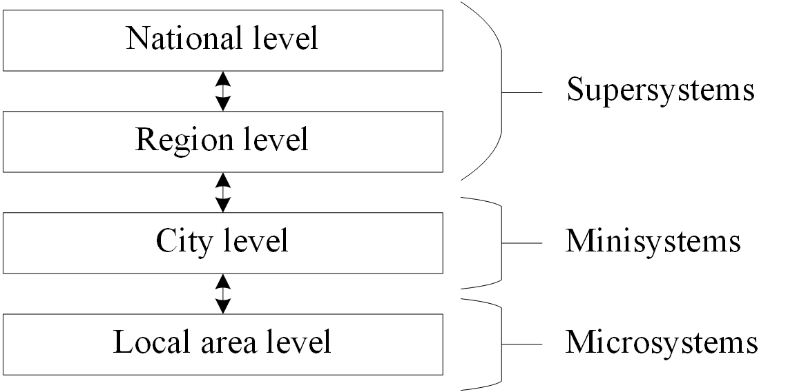
Fig. 1. Energy supply system levels.
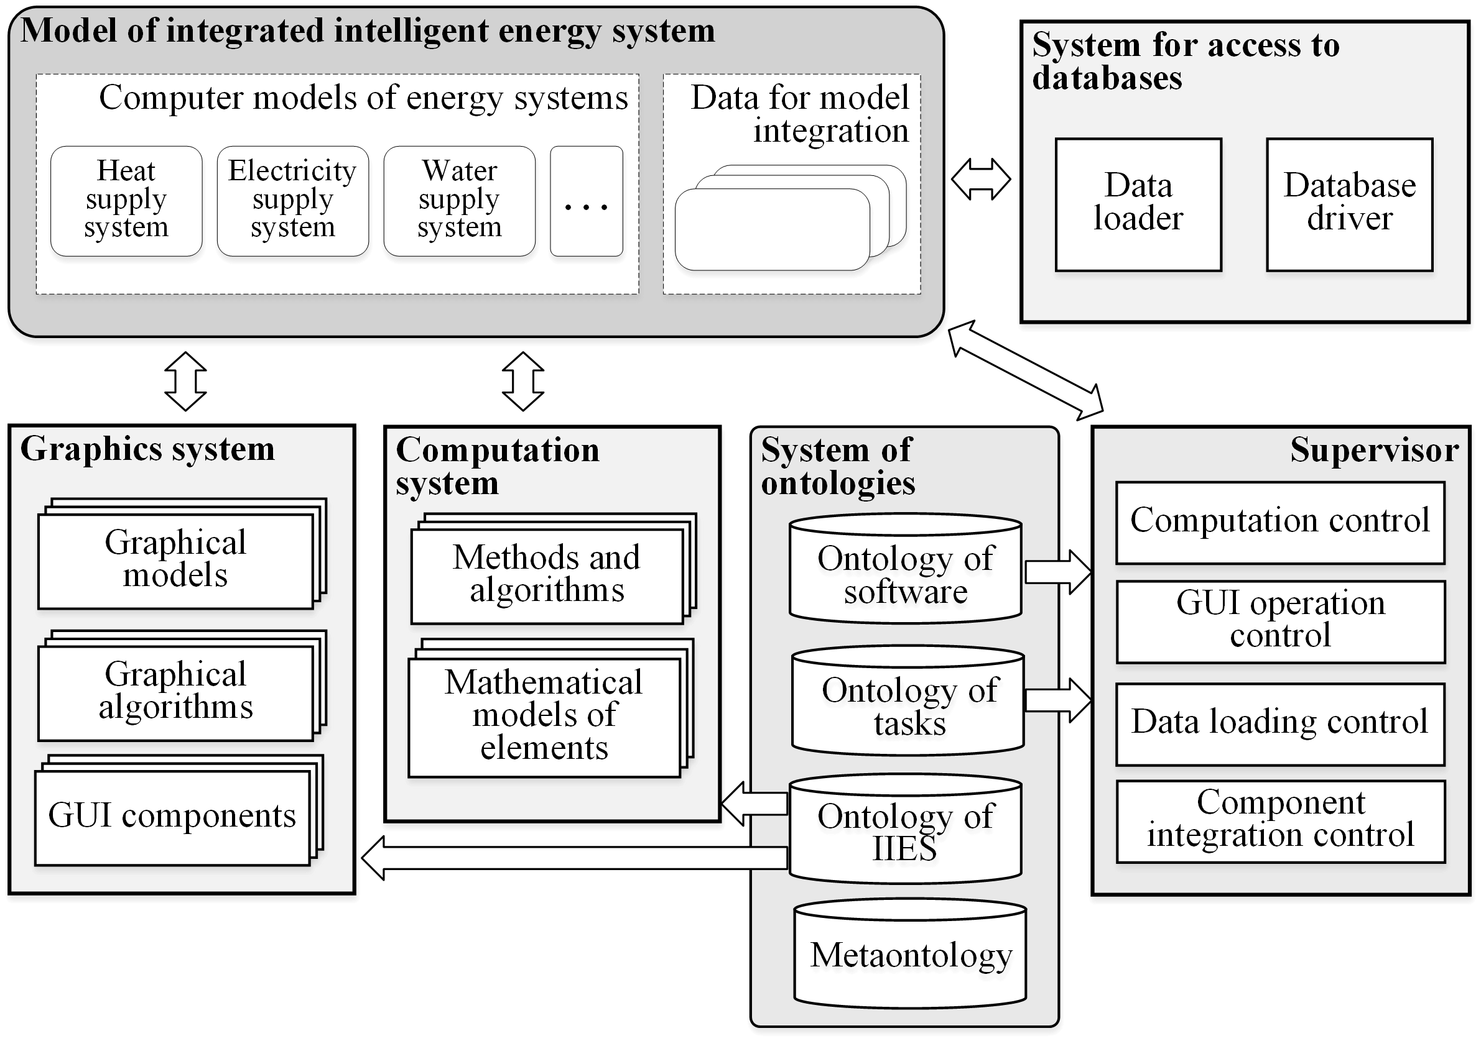
Fig. 2. Architecture of an information and communication platform for the study of integrated energy systems.

The implementation of integration in the functional aspect depends on the completeness, quality and relevance of the information. Such information can only be obtained through the implementation of modern digital technologies. At the same time, cybersecurity problems are aggravated [17, 18].
The complex for digitalization of the IES includes the following components:
• Digital devices.
• Digital models.
• Methodological support of digital modeling.
• Communication technologies.
• Information and intelligent technologies.
Digital devices will provide adaptive control and protection, complete monitoring of all elements of the energy supply system, distributed state estimation. Receiving, processing and representing information is carried out on the basis of digital technologies.
Digital modeling involves the development of digital models and the solution of a set of control tasks based on these models using the appropriate methodological support. The IES model is a set of data structures that describe the configuration of the system, the composition of its equipment and its characteristics, the state of the elements and their properties. Energy supply systems of various types, which are part of the IES, have common structural and topological properties and physical laws of energy transport, which allows us to formulate the following general provisions for the development of IES models:
• Modeling the IES in the form of a graph, the vertices of which correspond to nodes (sources, connection nodes, consumers), and arcs correspond to branches (pipelines, power lines, etc.).
• Representation of the IES computer model as a set of graph describing the configuration of this system, and a set of graphical and mathematical models describing the properties of its elements.
• Building hierarchical mathematical models of IES and solving tasks using multilevel modeling.
Methodological support for digital modeling of IES has the commonality of its conceptual and mathematical statements. The methods, algorithms and specialized software used to solve them can be universal. At the same time, various types of energy supply systems have their own individual characteristics, which must be taken into account in their digital modeling as part of an IES. For example, unlike other large energy systems and large pipeline systems, the operation of the heat supply systems is characterized by two parameters that are different in their physical essence: dynamic changes in flow and temperature are very different from each other. The flow rate in the network substantially changes without inertia. The process of propagation of a temperature wave through a heating network, which is determined by the flow velocity of the heat carrier, can last for hours.
When modeling IESs as new objects of research with the corresponding new properties and features, problems arise that appear, first of all, on the following issues:
• Aligning a common goal with the multiple goals of individual systems.
• Intersystem distribution and many decision-making centers.
• Development and implementation of an optimal strategy in general and for individual systems in particular.
• Solution of intersystem conflicts.
• Coordination of interests of suppliers and consumers.
• Coordination of multiple decision-making centers.
• Conjugation of hierarchical levels in each system and horizontal links between individual systems.
Communication technology. To ensure information exchange of data in the IES and its control, the use of digital communication networks and data exchange interfaces is provided. One of the most important goals is to ensure a continuous, manageable balance between the supply and demand of energy resources. For this, the network elements must constantly exchange information with each other about the parameters, modes of consumption and generation of energy resources, the amount and planned volume of energy consumption, and various commercial information.
Information and intelligent technologies. The large size of the IESs and the computational complexity of the models, methods and algorithms used do not allow the study of these systems without the use of specialized software. Information and intelligent technologies should ensure the solution of the whole set of tasks of expansion planning and operation control of IESs within a single information space. In fig. 2 shows the architecture of the information and communication platform for IESs research [19], developed at the Institute of Energy Systems named after L.A. Melentiev SB RAS to create a unified information space.
The creation of digital integrated energy systems requires not only the introduction of digital technologies into existing energy supply systems, but also the transition from their rigid existing hierarchical structure "generation - networks - consumers" to a more flexible one, in which each node of the system can be an active element. The new system design should combine a certain independence of many decision-making centers and their coordination to ensure sustainable energy supply to consumers.
5 Conclusion
Creation on the basis of several separately functioning mono-systems (electricity, heat / cold, gas supply and others) of a new energy technology structure in the form of an integrated energy system significantly expands their functionality, ensures the interchangeability of energy carriers and implements a synergistic effect to ensure reliable, safe, economical and environmentally friendly energy supply. The technological transformation of energy systems becomes possible due to the active development of modern digital technologies, telecommunications and information systems and their interpenetration, which allows the formation of flexible intelligent expansion planning and operation control of IESs, the coordination of individual subsystems and the implementation of system-wide targets. This leads to the emergence of new tasks of control of such systems and the need to develop methods for their solution, the study of properties, trends and patterns of development.
References
- M. Geidl, IEEE Transactions on Power Systems, 22, 145-155 (2007)
- A. Vasebi, M. Fesanghary, M.T. Bathaee, Electrical Power and Energy Systems, 29, 713-719 (2007)
- Z. Li, Z. Huo, H. Yin, Asia-Pacific Power and Energy Engineering Conference (IEEE, Wuhan, 2011)
- N.I. Voropai, V.A. Stennikov, Izvestiya RAN. Energetika, 64-73, (2014) (in Russian)
- M. Geidl, G. Andersson, European Transactions on Electrical Power, 16, 463-477 (2006)
- M. Geidl, G. Koeppel, P. Favre-Perrod, B. Klockl, G. Andersson, K. Frohlich, IEEE Power and Energy Magazine, 5, 24-30 (2007)
- M. Almassalkhi, I. Hiskens, 17th Power System Computation Conference (Stockholm, 2011)
- N.I. Voropai, V.A. Stennikov, E.A. Barakhtenko, O.N. Voitov, I.V. Postnikov, Energy Systems Research, 1, 57-66 (2018)
- J. Momoh, Smart Grid: Fundamentals of design and analysis (2012)
- S. Le Blond, T. Lewis, M. Sooriyabandara, 2nd IEEE PES International Conference and Exhibition on Innovative Smart Grid Technologies (IEEE, Manchester, 2011)
- P. Mancarela, Chin Kim Gan, G. Strbac, 17th Power System Computation Conference (Stockolm, 2011)
- N.I. Voropai, E.V. Ukolova, D.O. Gerasimov, K.V. Suslov, P. Lombardi, P. Komarnicki, Vestnik IrGTU, 22, 157-168 (2018) (in Russian)
- I. van Beuzekom, M. Gibescu, J.G. Slootweg, 2015 IEEE Eindhoven PowerTech (IEEE, Eindhoven, 2015)
- R. Bent, S. Blumsack, P. Van Hentenryck, C. Borraz-Sánchez, M. Shahriari, IEEE Transactions on Power Systems, 33, 6397-6409 (2018)
- N.I. Voropai, V.A. Stennikov, E.A. Barakhtenko, Studies on Russian Economic Development, 28, 492-499 (2017)
- N.I. Voropai, A.B. Osak, Energeticheskaya politika, 60-63 (2014) (in Russian)
- N.I. Voropai, I.N. Kolosok, E.S. Korkina, A.B. Osak, Proceedings of the 10th International Conference "Electric Power Through the Eyes of Youth-2019" (Samara, 2019)
- L. Massel, N. Voropay, S. Senderov, A. Massel. Voprosy kiberbezopasnosti, 2-10 (2016)
- Barakhtenko E., Sokolov D., 2019 International Multi-Conference on Industrial Engineering and Modern Technologies (IEEE, Vladivostok, 2019)

