Technological forecasting related to the energy sector: a scientometric overview

Alexey V. Mikheev

Melentiev Energy Systems Institute of Siberian Branch of the Russian Academy of Sciences,

130, Lermontov str., 664033  
Irkutsk, Russia

E-mail: [avmiheev@gmail.com](mailto:avmiheev@gmail.com)

**Abstract**

Scientometric review of trends and key points of technological forecasting related to the energy sector is carried out in this study. Using co-keyword, co-citation techniques to analyze a set of research and review articles indexed in the Scopus database, clustered networks were built to understand content relationships and research topic evolution within the 2000-2019 period. This study provides an overview of future-oriented research efforts and trends in the energy technology knowledge domain.

*Keywords*: energy technology, technology forecasting, scientometric analysis, visual analysis, VOSviewer, CiteSpace.

# Introduction

Technology forecasting is usually determined as decisive and systematic attempts to anticipate and understand the potential direction, rate, characteristics, and effects of technological changes, especially invention, innovation, adoption, and use [1]. In [2] the group of experts systematizes methods and forms of technology forecasting within a future-oriented technology analysis framework. They distinguish several overlapping forms of technology forecasting such as:

* technology monitoring, watch, alerts (gathering and interpreting information);
* competitive intelligence (converting that information into usable intelligence);
* technology forecasting (anticipating the direction and pace of changes);
* technology roadmapping (relating anticipated advances in technologies and products to generate plans);
* technology assessment (anticipating the unintended, indirect, and delayed effects of technological changes);
* technology foresight (effecting development strategy, often involving participatory mechanisms).

In recent decades, the works [3] and [4] review the families of technology forecasting methods, its relationships, and applications. Nevertheless, there are no general overviews of technology forecasting evolution applied to the energy sector. This research tries to investigate the impact of energy technology forecasting in the scientific literature.

The energy technology forecasting concept is not always used to imagine prospects and the coming advances in the energy area. Many works anticipating future energy technologies use “technological change” or widely discussed “energy transition” toward sustainable development by transitioning from fossil-based to zero-carbon energy resources [5]. So these concepts should be additionally involved in the consideration.

The main goals of this study:

* summarizing the recent existing research efforts on energy technology forecasting;
* helping to systematically understand the co-citation documents, term clusters, and keywords clusters, as well as the knowledge pattern of energy technology forecasting;
* quantitative estimation of the status quo and development trend of energy technology forecasting;
* visualization of the research landscape of technology forecasting in the energy area.

# Methodology, data, and tools

The methodology of the study is a scientometric analysis joint with supporting visualization to provide an in-depth understanding of the research structure and trending topics in energy technology forecasting. The scientometric analysis is a well-established technique to construct a knowledge map of the specific area over a large massive dataset of scientific literature. An example of a scientometric review of global research on sustainability and sustainable development can be found in [6]. General workflow of scientometric analysis includes several sequential steps:

1. Publications data retrieval related to a specific problem or knowledge area.
2. Data cleaning manually or automatically to remove irrelevant publications.
3. Scientometric quantitative analysis applying various metrics like betweenness centrality, burst strengths to construct different co-occurrence networks. The network examples are co-authorship network, co-word network, co-terms network, co-citations network, and others. Further cluster analysis over the constructed networks is also a part of the scientometric approach.

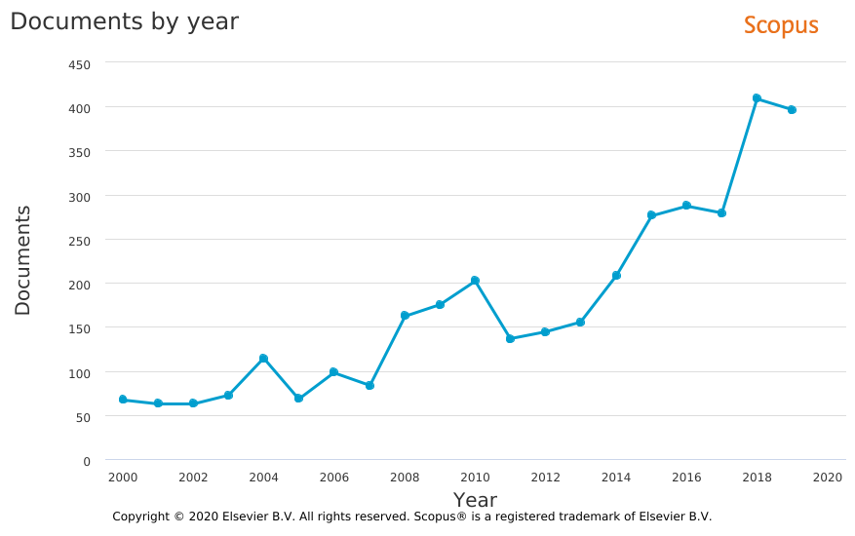

a)

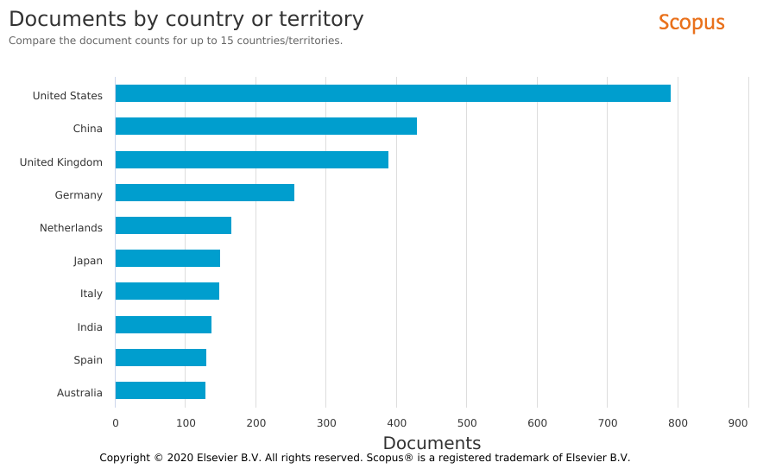

b)

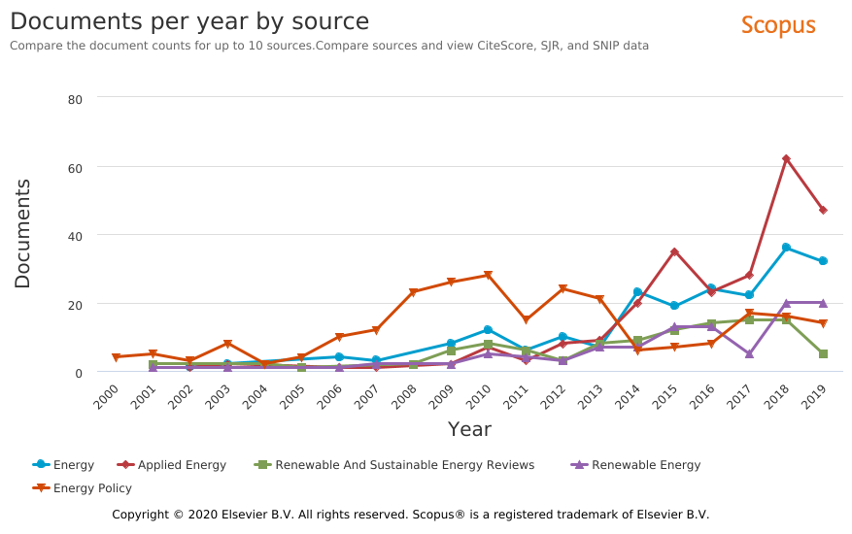

c)

Fig. 1. The number of articles on energy technology forecasting in the Scopus database: (a) during period 2000–2019, (b) country distribution, (c) most productive journals.

1. Knowledge domain visualization and in-depth analysis to obtain status-quo of research, discover emerging trends, hidden interrelations, and other valuable outputs.

In the study, the Scopus database was selected as the most comprehensive and easy-to-use data source. A search in the database was carried out using the base word “energy” and a specific set of additional words related to concepts of future-oriented technology analysis. The last concept has fuzzy semantics and includes such terms as “technology forecasting”, “technology foresight”, “technology monitoring”, “technology roadmapping”, “technology trend”, “technology assessment”, “technology change”, “technology transition” and so on. Symbol “*” is inserted instead of the end of some words to satisfy a fuzzy search. The publications with the language “English” and document type as “Article”, “Review” from reviewed and trusted journals were selected. We consider the period 2000–2019 when the rapid growth of publications in the Scopus database is observed.

The final query text inserted in the bar of “Advanced search” of the Scopus search engine is presented below.

TITLE-ABS-KEY ( energy AND ( "technol* forecast*" OR "forecast* technol*" OR "technol* trend*" OR "technol* monitoring" OR "technol* chang*" OR "technol* transit*" OR "technol* transform*" OR "emerging energy technol*" OR "technol* assess*" OR "technol* roadmap*" OR ( technolog* AND "future prospect*" ) ) ) AND (LIMIT-TO ( DOCTYPE , "ar" ) OR LIMIT-TO ( DOCTYPE , "re" )) AND (LIMIT-TO ( LANGUAGE , "English" ) )

To avoid including irrelevant documents, for example from medical science, the search results were filtered to remove the subject areas far from “Energy” like “Medicine”, “Nursery”, “Computer Science”, “Arts and Humanities”, etc. On the other hand, since the “energy” is a multidisciplinary topic, such subject categories as “Engineering”, “Chemistry”, “Environmental Science”, “Social Science”, “Material Science” and so on also remain under consideration.

The search with this query gives 3448 articles. Fig. 1 presents the document statistics by years, countries, and sources provided by the standard Scopus tool.

To investigate semantic content, key topics, and its corresponding interrelations the two scientometric techniques were used in this study, namely, co-citation analysis and co-term (keyword) analysis.

In this paper, two software tools are used for scientometric analysis. First, VOSviewer software pays special attention to displaying large bibliometric maps in an easy-to-interpret way [7]. Another one is CiteSpace, which is a very powerful and extremely featured application for analyzing and visualizing co-citation scientific networks [8]. The application developed by Chaomei Chen has rich possibilities to identify the emerging trends and general points in a specific domain.

# Results of scientometric analysis

Initially, the co-occurrence network based on the article’s keywords was generated with VOSviewer. General terms like “article”, “review”, “technology” were excluded from the keywords list summarized from all articles. The visualization of the clustered network graph is shown in Fig. 2.

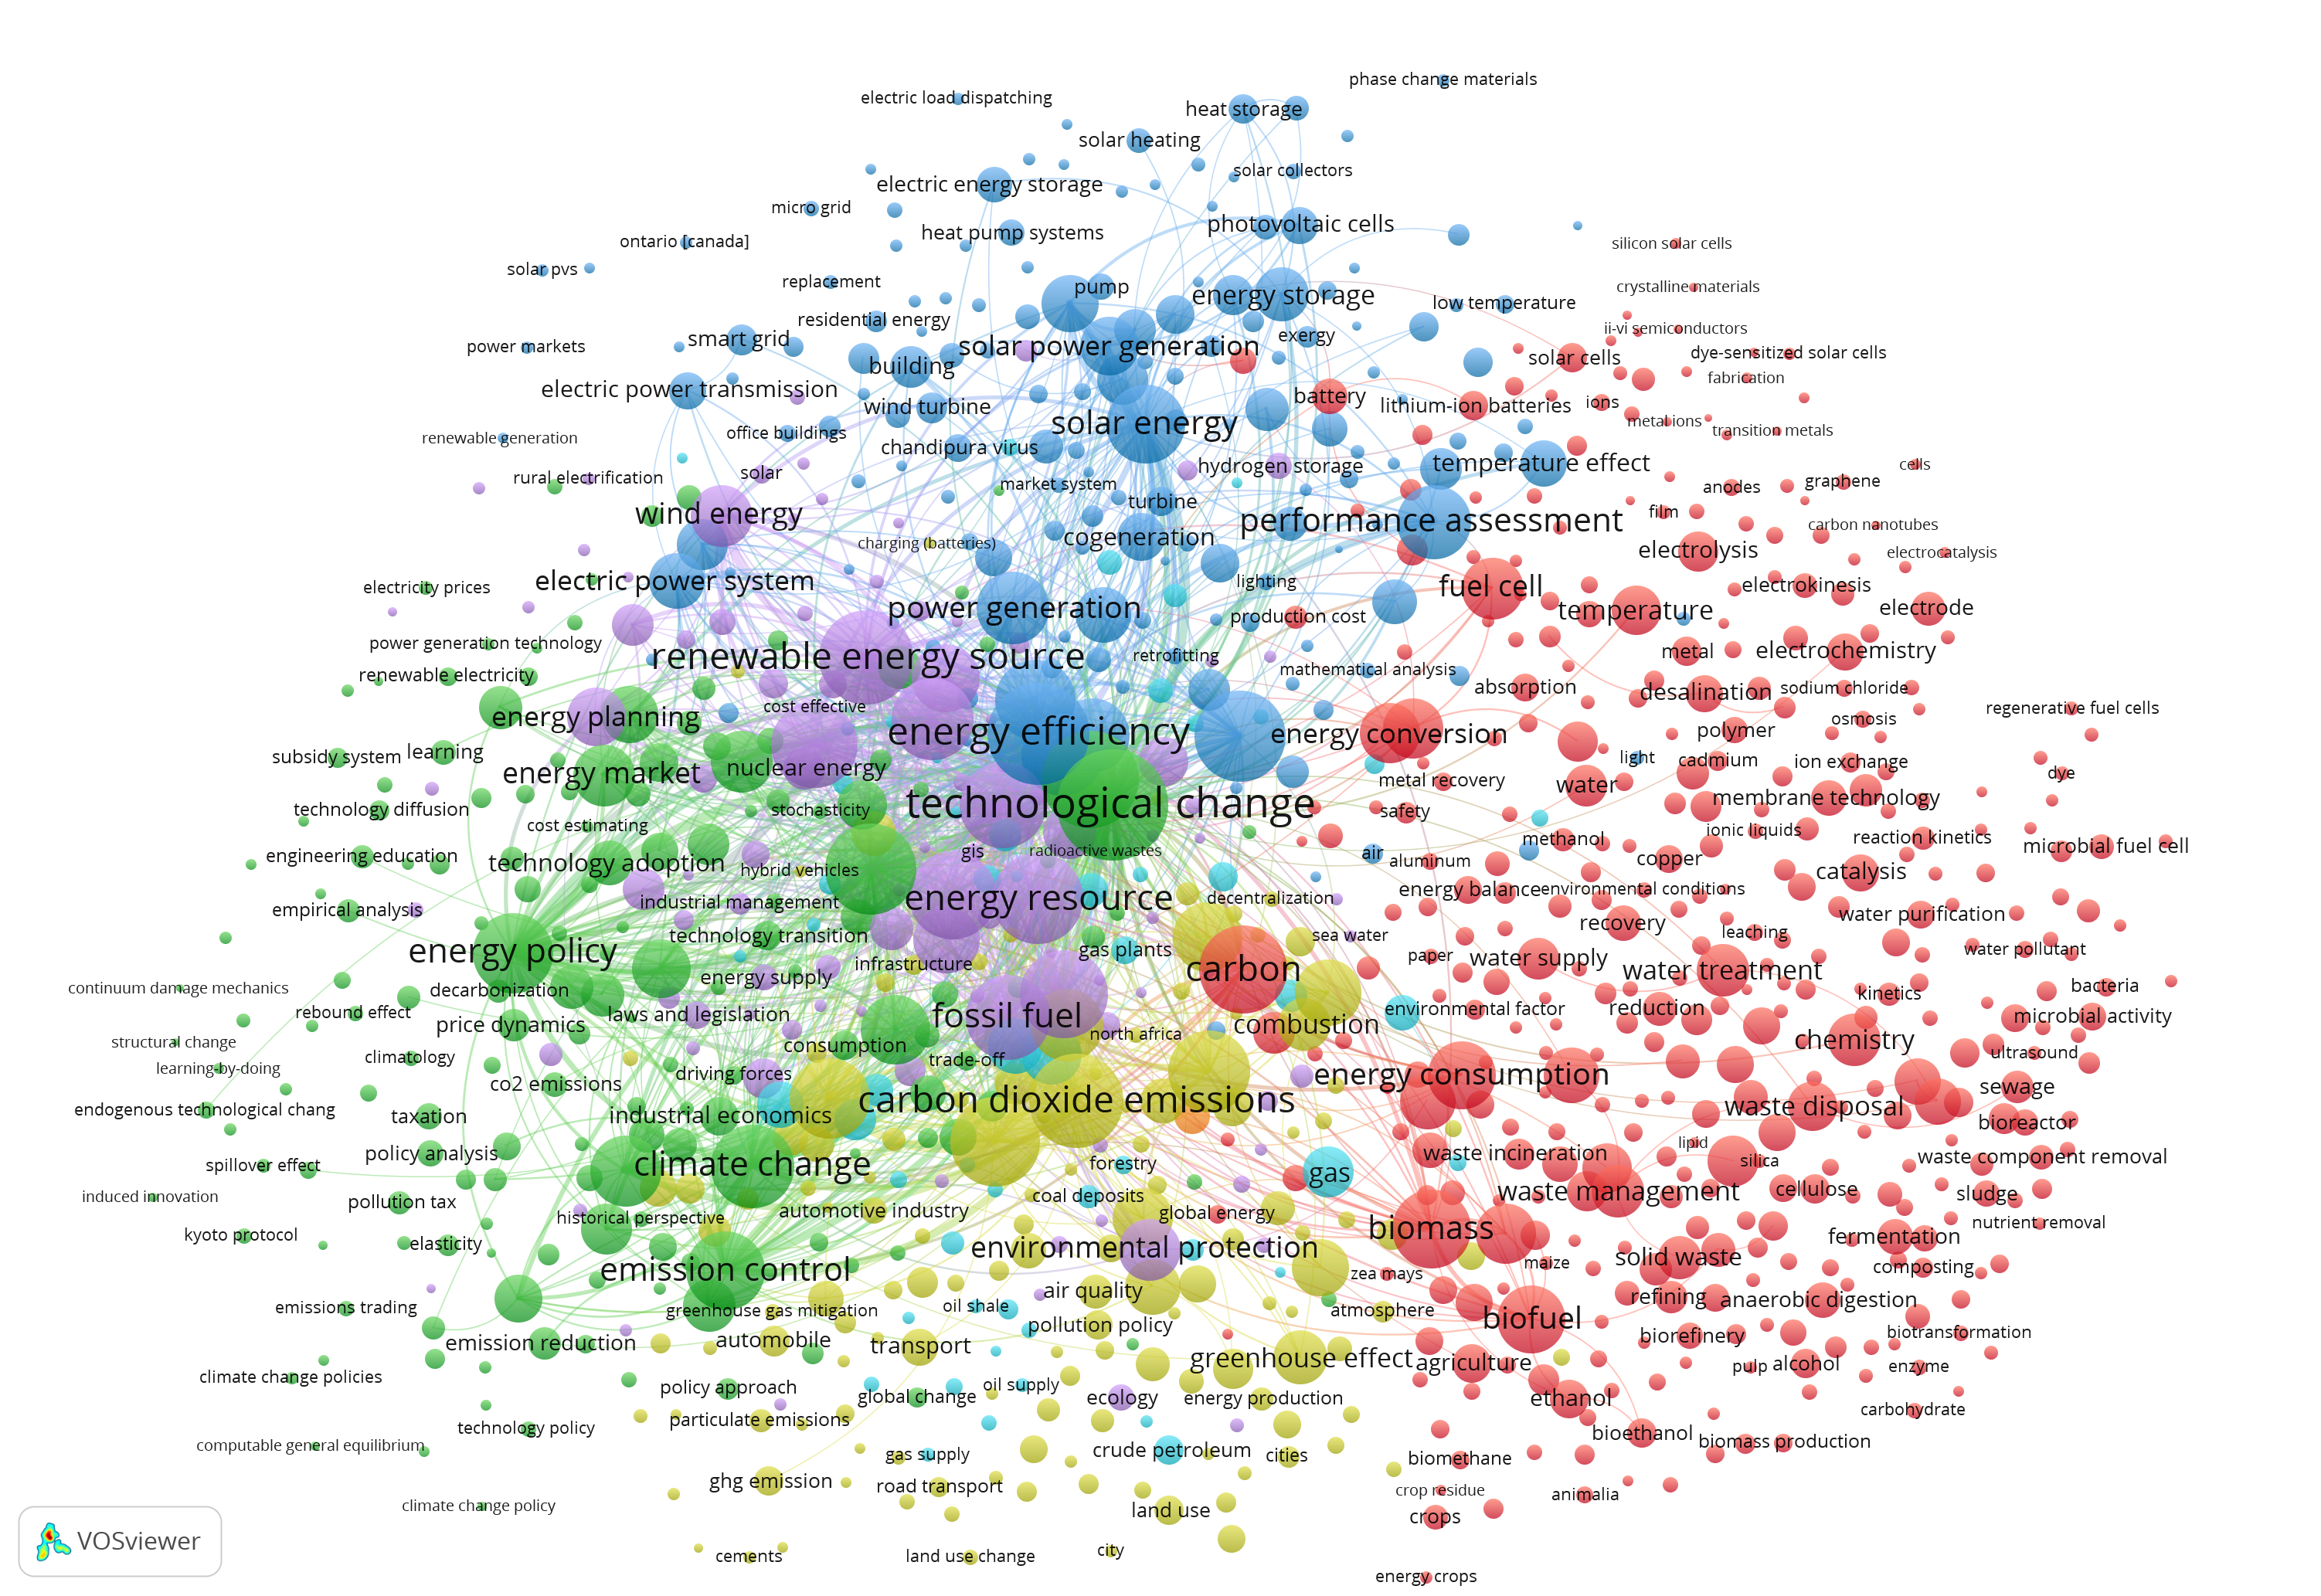

Fig. 2. Colored clusters of keywords co-occurrence network generated using VOSviewer software.

Several colored clusters found over the keywords network reflect the main research topics of two recent decades. Technological change implies the advancement of renewable energy resources such as wind energy and solar energy (mixed violet and blue clusters). The red cluster contains another class of renewable energy technologies based on biomass. The bioenergy cluster is linked to renewable solar and wind technologies through hydrogen technologies including fuel cells. The green cluster presents energy policy issues including planning and market development for renewable energy sources on the one hand. On the other hand, climate change and emission control issues are directly related to environmental protection and carbon dioxide emissions topics located in the yellow cluster. Such general terms as energy efficiency, energy conversion, energy consumption, performance assessment, electric power system development, and other issues remain important research topics.

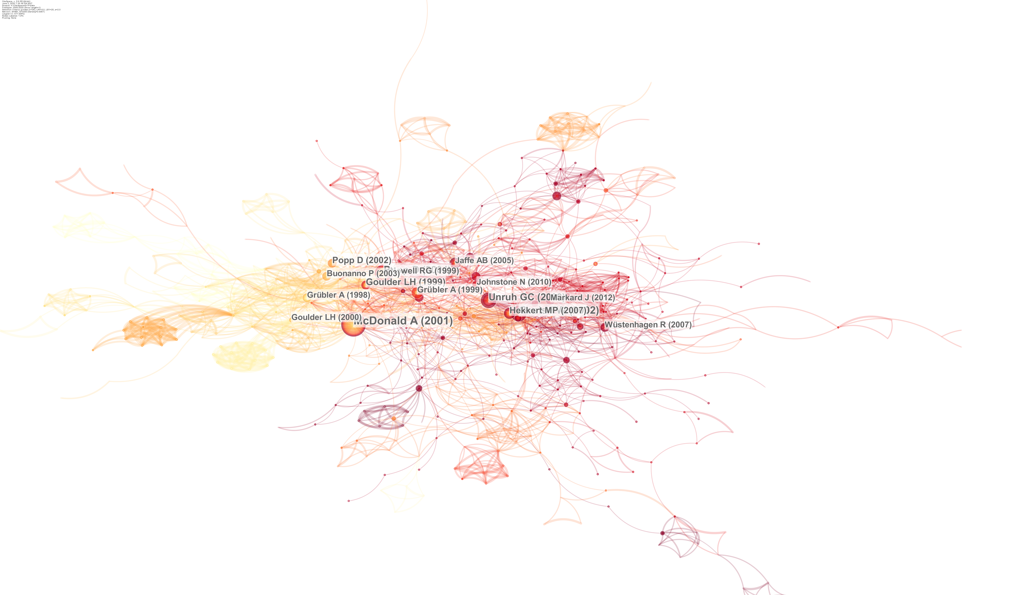



2000 2005 2010 2015 2019

Fig. 3. Co-citation network from publications of Scopus database over period of 2000-2019 years.

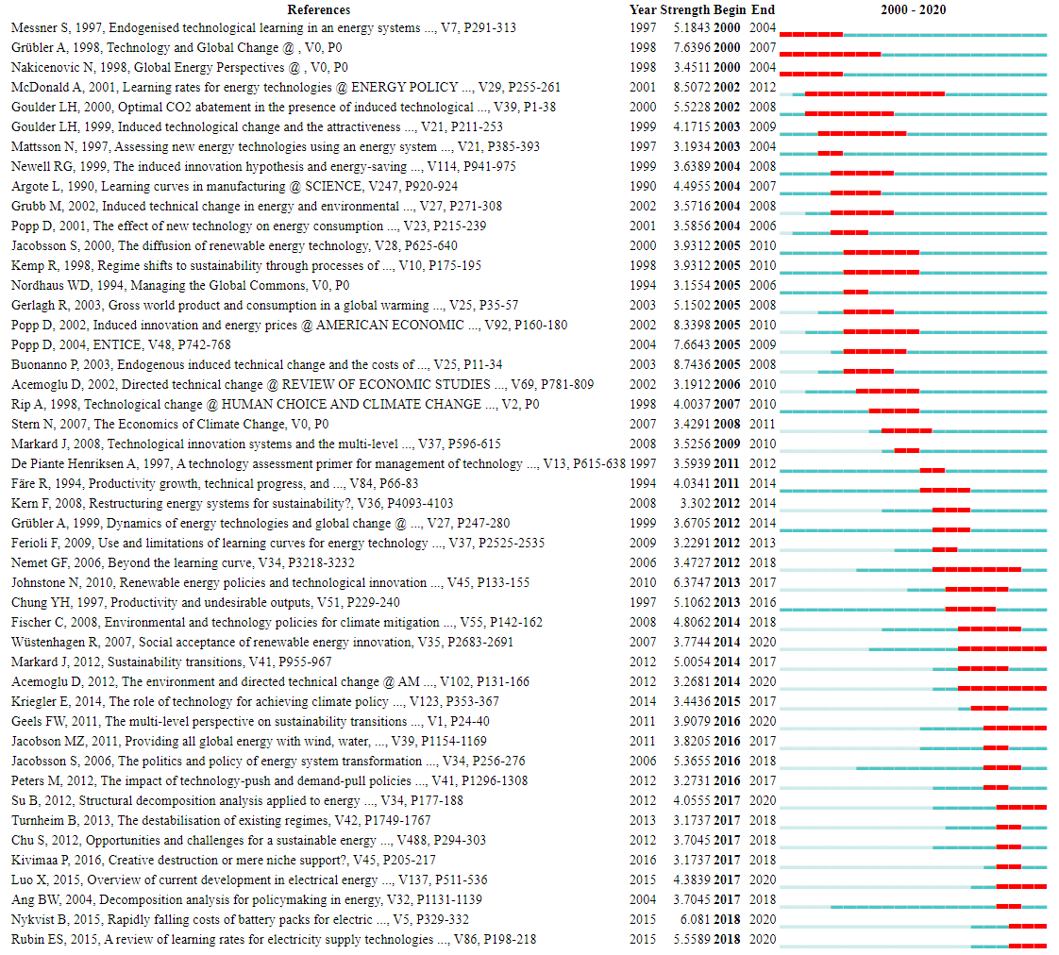

Fig. 4. Top 47 papers with strongest citation bursts. Most intensive citation period is selected by red color.

Generating a co-citation network using CiteSpace software with default parameters is the next step of the analysis. For the correct construction of the co-citation network, the publications of the years preceding 2000 were also included to take into account previous research impact. Co-citation network in Fig. 3 presents an evolution of technology forecasting research from 2000 to 2019 years. It’s observed that the presented co-citation graph becomes sparser during the last decade 2010-2020.

The list of top 47 papers having the strongest citation burst is shown in Fig. 4. These papers are sorted by start year of burst to show the dynamics of the most “hot” topics and documents along with the considered period. In the early and middle 2000s, the learning rates of energy technologies to assess forthcoming technological changes were the most important subject of interest for researchers. A highly cited research study [9] by Alan McDonald and Leo Schrattenholzer considers assembled data on cost reductions for many energy technologies to estimate learning rates. During the 2010s the sustainable technological transition to renewable energy sources receives special attention as an important issue of energy policy.

# Conclusions

A preliminary scientometric overview was carried out for the research domain of energy technological forecasting. General trends of technology forecasting in the energy sector were quantitatively estimated and visualized. The findings show the research spectrum from environmental policy issues like climate change and emission control to a set of alternative energy technologies including solar, wind, biomass, and hydrogen technologies. However, to discover non-evident topics and relationships the more deep analysis is needed together with further comprehensive critical review similar to the methodology used in [10]. This analysis can also be improved on the base of the iterative procedure using preliminary prepared hierarchical concept maps or applied ontologies of energy technologies and forecasting methods.

# Acknowledgments

The research is funded by the Russian Foundation for Basic Research (project No. 20-07-00994).

References

1. V. Coates, M. Faroque, R. Klavins et al. On the future of technological forecasting. Technol. Forecast. Soc. Change, 67 (1), 2001. pp. 1 – 17.   
   <https://doi.org/10.1016/S0040-1625(00)00122-0>
2. Technology Futures Analysis Methods Working Group, Technology Futures Analysis: Toward Integration of the Field and New Methods, Technological Forecasting and Social Change, Vol. 71, 2004. pp. 287-303.
3. Firat, A.K., Woon, W.L., Madnick, S. Technological Forecasting – A Review, Working Paper, Massachusetts Institute of Technology, Report, USA, 2008.
4. Haleem, A., Mannan, B., Luthra, S., Kumar, S. and Khurana, S. Technology forecasting (TF) and technology assessment (TA) methodologies: a conceptual review, Benchmarking: An International Journal, Vol. 26 No. 1, 2019, pp. 48-72. <https://doi.org/10.1108/BIJ-04-2018-0090>
5. Grübler, A., Nakićenović, N., & Victor, D. G. Dynamics of energy technologies and global change. Energy Policy, 27(5), 1999. pp. 247–280. <https://doi.org/10.1016/S0301-4215(98)00067-6>
6. Olawumi, T. O., & Chan, D. W. M. A scientometric review of global research on sustainability and sustainable development. Journal of Cleaner Production, 183, 2018. Pp. 231–250. <https://doi.org/10.1016/J.JCLEPRO.2018.02.162>
7. Van Eck, N. J., & Waltman, L. Software survey: VOSviewer, a computer program for bibliometric mapping. *Scientometrics*, *84*(2), 2010. 523–538.   
   <https://doi.org/10.1007/s11192-009-0146-3>
8. Chen, C., Song, M. Visualizing a field of research: A methodology of systematic scientometric reviews. PLoS ONE, 14(10), 2019.   
   <https://doi.org/10.1371/journal.pone.0223994>
9. McDonald, A., & Schrattenholzer, L. Learning rates for energy technologies. Energy Policy, 29(4), 2001. pp. 255–261. <https://doi.org/10.1016/S0301-4215(00)00122-1>
10. Zhong, B., Wu, H., Li, H., Sepasgozar, S., Luo, H., & He, L. (2019). A scientometric analysis and critical review of construction related ontology research. *Automation in Construction*, *101*, 2019. pp. 17–31. <https://doi.org/10.1016/J.AUTCON.2018.12.013>